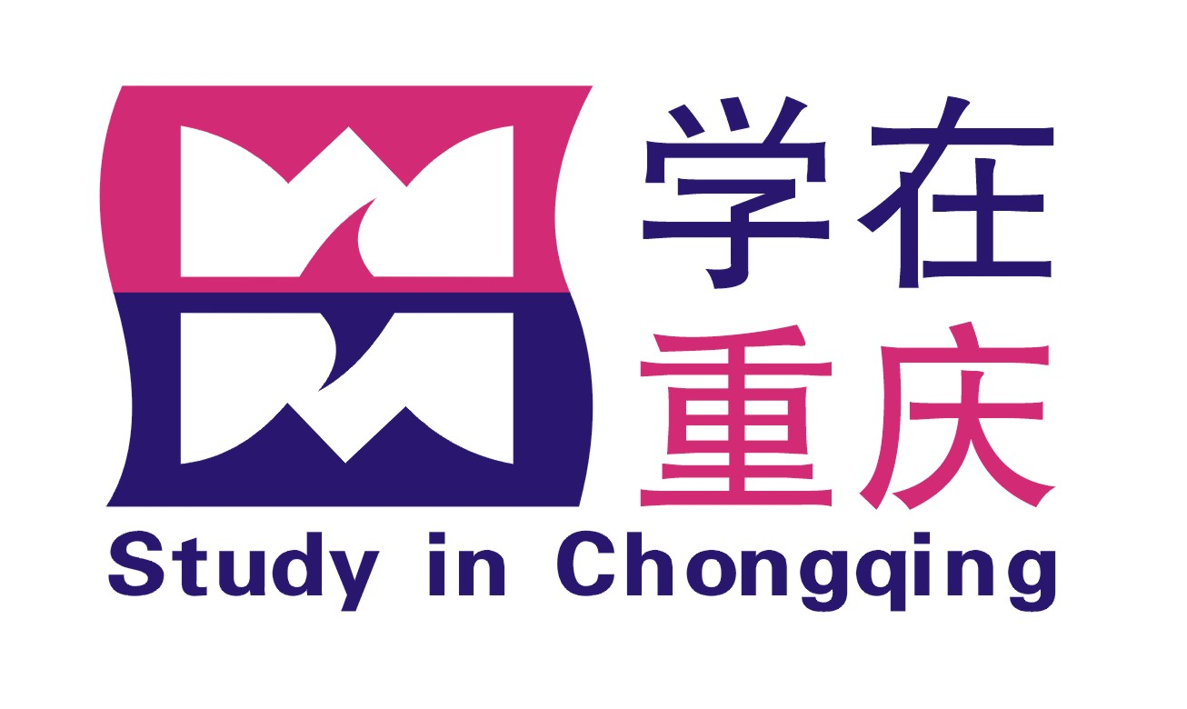
重庆市教育委员会
No.
学生类别
学习专业
CHONGQING MUNICIPAL EDUCATION COMMISSION
中国重庆市江北区北滨一路369号 邮编：400020

Add: No.369 Beibinyilu Road, Jiangbei District, Chongqing，P.R. China 400020
http//:www.cq.edu.cn (学校填写The above table is only for
Chinese higher education institutions)

重庆市人民政府外国留学生市长奖学金申请表
APPLICATION FORM FOR CHONGQING MUNICIPAL GOVERNMENT
MAYOR SCHOLARSHIP

请用中文或英文填写此表格。请用电脑打印或用蓝色或黑色钢笔认真书写表格内容，请在所选项框内划‘X’表示。不按规定填写的表格将视作无效。
Please complete the form in Chinese or English. If the form is not filled in on PC, please write legibly in black or blue ink. Please indicate with ‘X’ in the blank chosen. Any forms that do not follow the notes will be invalid.

1. 申请人情况/Personal Information
照片
Photo
护照用名/Passport Name
姓/Family Name
名/Given Name
国籍/ Nationality 护照号码/ Passport No.
出生日期/Date of Birth: 年/ Year 月/ Month 日/ Day
出生地点/ Place of Birth: 国家/Country 城市/City
男/Male □ 女/Female □ 已婚/Married □ 未婚/Single □ 其它/Other □
母语/Native Language 宗教/Religion
当前联系地址/ Present Address
电话/Tel 传真/Fax E-mail
永久通信地址/Permanent Address
接收录取通知书地址（包含国家、省州、城市、街道、邮编信息）/Address for receiving admission notice(Street, City, State/Province, Country, Zip code)

2. 受教育情况/Education Background
学校 在校时间 主修专业 毕业证书及学位证书
Institution Years Attended (from/to) Fields of Study Certificates Obtained or To Obtain

3. 工作经历/Employment Record
工作单位 起止时间 从事工作 职务及职称
Employer Time(from/to ) Work Engaged Posts Held

4. 语言能力/Language Proficiency)
a) 汉语/Chinese: 很好/Excellent □ 好/Good □ 较好/Fair □ 差/Poor □ 不会/None □
HSK考试等级或其他类型汉语考试成绩/Level of HSK test or other certificates which can show your Chinese level:

b) 英语/English: 很好/Excellent □ 好/Good □ 较好/Fair □ 差/Poor □ 不会/None □
申请授课语言/Language of Instruction：汉语/Chinese □ 英语/English□
我的英语水平可以用英语学习/I can be taught in English: 是/Yes □ 否 /No □
c) 其他语言/Other Languages:

5. 来华学习计划/Proposed Study in China
a) 博士研究生/Doctoral Degree Candidate: □ 硕士研究生/Master’s Degree Candidate: □
本科生/Bachelor’s Degree Candidate: □ 进修生/Further-study Student: □
b) 申请来华学习专业或研究专题/Subject or Field of Study in China:
c) 申请院校/Preferences of Institutions of Higher Education in Chongqing:
Ⅰ. Ⅱ. Ⅲ.
d) 申请来华专业学习时间/Duration of the Major Study in China:
自/From: 年/Year 月/Month 至/To: 年/Year 月/Month
e) 是否需要补习汉语/Do You Need Elementary Chinese Study Prior to the Major Study?
是 /Yes: □ 请填写申请汉语补习时间（不计在专业学习时间）/If “Yes”, please fill in the duration of your elementary Chinese study (not included in the length of the major study ).
否 /No: □
6. 拟在华学习或研究的详细内容（可另附纸）/Please describe the details of your study or research plan in China (an extra paper can be attached if this space is not enough)

7. 曾发表的主要学术论文、著作及作品/Academic Papers, Writing & Art Works Published

8. 申请人在华事务联系人或机构/ The Guarantor Charging Your Case in China:
名称/Name: 电话/Tel: 传真/Fax:
地址/Address:

9. 申请人是否曾在华学习或任职/Have you ever Studied or Worked in China?
是/Yes □ 学习或任职单位/Institution or Employer
在华时间/Time in China: 自/From: 年/Year 月/Month 至/To: 年/Year 月/Month
否/No □

10. 申请人亲属情况/Family Member of the Applicants:
姓名 Name 年 龄Age 职业Employment
配偶/Spouse:
父亲/Father:
母亲/Mother:

所附材料情况（请在所附附件前划‘X’标明）/Materials Attached (Please Indicate with ‘X’ in the Bracket.):
□ 两封副教授或教授推荐信/Two Letters of Recommendation by associate professors or professors.
□ 有关重庆院校接受函或录取通知书/Admission Letter or Admission Notice of Universities in Chongqing .
□ 本人最后学历成绩单复印件（须公证）/Transcripts of the Most Advanced Studies (Notarized Photocopy).
□ 本人最后学历证书复印件（须公证）/Diploma of the Most Advanced Studies (Notarized Photocopy)：
本科/Bachelor’s □ 硕士/Master’s □ 博士/Doctor’s □ 其它/Others □
□ 外国人体格检查记录（复印件）/ Foreigner Physical Examination Form (Photocopy).
□ 来华学习计划/ Study Plan in China.
□ 所发表的文章等/ Articles or Papers Published (Photocopy).
□ 美术作品（本人作品彩照六张）、音乐作品（本人音乐作品盒式录音带一盘）（只限申请美术和音乐专业的申请人）/Examples of Art (6 color pictures) and Music (1 audio tape) Work (Only for the applicants applying for Fine Arts and Music).
□ 其它附件（请列出）/Other Attachments (List Needed)：__________________________________________________________
注：每份申请材料最多不超过20页，请全部使用A4纸。
Each set of the complete materials should not exceed 20 pages. Please use DIN A4.
无论申请人是否被录取，上述申请材料恕不退还。
Whether the candidates are accepted or not, all the application materials will not be returned.

申请人保证/I Hereby Affirm That: .
1. 申请表中所填写的内容和提供的材料真实无误；
All the information and materials given in this form are true and correct.
2. 在华期间，遵守中国的法律、法规，不从事任何危害中国社会秩序的、与本人来华学习身份不符合的活动；
During my stay in China, I shall abide by the laws and decrees of the Chinese government, and will not participate in activities in China which are deemed to be adverse to the social order of China and are inappropriate to the capacity as a student.
3. 在学期间，遵守学校的校纪、校规，全力投入学习和研究工作，尊重学校的教学安排；
During my study in China, I shall abide by the rules and regulations of the host university, concentrate on my study and researches and follow the teaching programs arranged by the university.
4. 按照规定参加重庆市人民政府外国留学生市长奖学金年度评审；
I will go through the procedures of the Annual Review of Chongqing Municipal Government Mayor Scholarship as required.
5. 按规定期限修完学业，按期回国，不无故在华滞留；
I shall return to my home country as soon as I complete my scheduled program in China and will not extend my stay unreasonably.
6. 我保证，未同时接受其它任何渠道的奖学金或资助；
I declare that this is the only Scholarship I am applying for at present.
7. 如违反上述保证而受到中国法律、法规或校纪、校规的惩处，我愿意接受重庆市教育委员会中止或取消奖学金及其它相应的处罚。
If I am judged by the Chinese laws, decrees and the rules and regulations of the university for having violated any of the above, I will not lodge any appeal against the decision of Chongqing Municipal Education Commission on suspending, withdrawing this scholarship or other penalties.
申请人签字/Signature of Applicant: 日期/Date:
（无此签名，申请无效/The application is invalid without the applicant’s signature）

