Description of a problem issued originally under NAIT-24462 error in KA107 application
Description of the error:
In KA107 form for 2016 there is an error that can cause absence of one subsection for particular country from list of countries mentioned in activities' flows. In section D.1. Activities' Details of the form, user defines flows for particular activity. According to the rule
[THIS SECTION IS REPEATED FOR EACH UNIQUE PARTNER COUNTRY MENTIONED AS ORIGIN OR DESTINATION IN THE FLOWS OF ANY ACTIVITY]
the Quality questions section (section F) should be displayed for each (unique) country mentioned in the activities' flows.
Due to the error, Quality questions are sometimes not displayed for all mentioned countries. 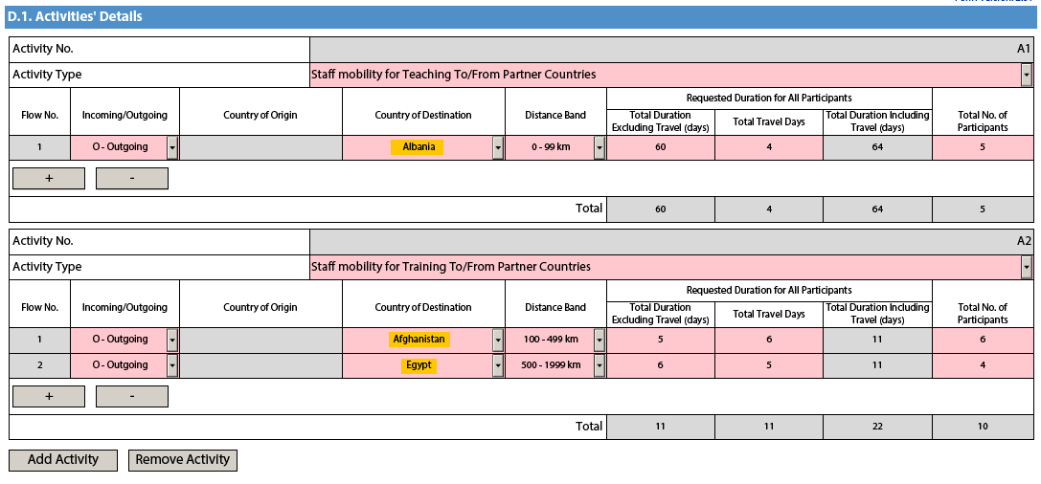
We have 3 countries here: Albania, Afghanistan and Egypt. Therefore, Quality questions subsection should be displayed 3 times, once per country. Unfortunately, due to the error, sometimes form does not display sections for all countries, which means the user has no possibility to answer Quality questions for all mentioned countries. This does not generate any validation error and user can submit the form without noticing that some parts are missing (especially, in case of many countries).
In this example, in section F Quality questions we have only two instead of three sections.
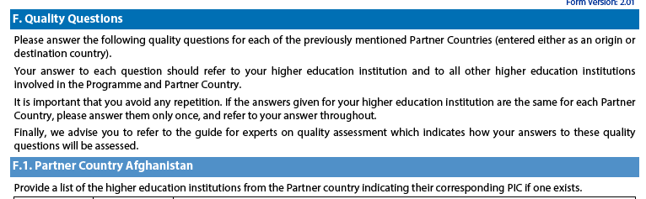
And later
The section for Albania is missing.
Reproduction of the error:
This problem occurs when user is entering Country of Origin or Country of Destination (depending on whether it's Outgoing or Incoming flow) by entering first letter(s) of the country name from keyboard. This does not happen every time, but usually, after 3rd or 4th attempt the error occurs.
Workaround solution:
To our best knowledge, this problem occurs only when user enters letters as it is described above. To avoid any problems, countries in section D.1. Activities' Details should be selected by mouse. User should expend the list and select the country from it by using mouse, not keyboard.
Variations:
- Sometimes this error cases missing country in section D.1.1 Summary of Activities and Participants per Partner Country
- Sometimes, after country is changed in the flow definition, section F is not refreshed and there is section displayed for country which is no longer mentioned in section D.1. Activities' Details
Both of those variations are solved by selecting countries by mouse, as it is described above.
Final advise:
We advise users to double check (manually) the list of countries mentioned in section D.1. Activities' Details with the:
- section D.1.1 Summary of Activities and Participants per Partner Country
- section F Quality questions
To be sure, that form displays all necessary section correctly.
In case any country is missing, user should:
- Move back to section D.1. Activities' Details
- Locate the "missing" country in flows
- Select by mouse different country (does not matter which one) instead of "missing" one
- Wait for the form to re-display the section (this takes usually less than a second)
- Select again the intended country by mouse.
- Check if all sections are displayed correctly.

