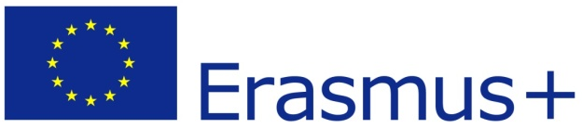
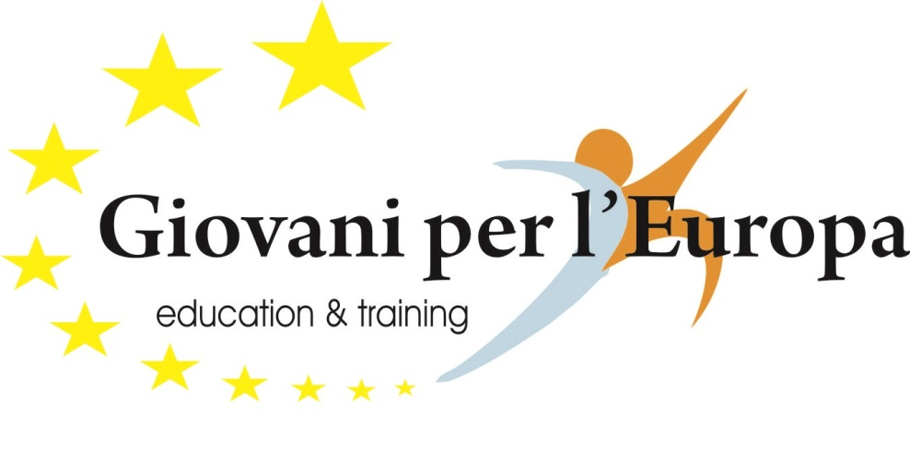
PIC number: | 948770872
Full legal name | GIOVANI PER L’EUROPA
Full legal name (English)
Acronym
Address | Corso Umberto I
City | Nicotera
Country | Italy
Region | Calabria
Email | info@giovaniperleuropa.org
Facebook | https://www.facebook.com/giovaniperleuropa.org?ref=hl
Otlas
Type of organisation/code: EDU-VET
Regional code: IT F6
Number of staff: S1
Type of Organization | Non-profit organisation
Is the partner org. a public body? | NO
Is the partner org. a non-profit? | YES

Legal Representative and Contact
Title, Family Name | Mr.
First Name | FERDINANDO COMERCI
Position | President
Email | ferdinando@giovaniperleuropa.org
Telephone | +39 0963 82105
Adress | Corso Umberto I, 89844 Nicotera (VV)
Please briefly present the partner organisation

Giovani per l’ Europa is a European Vocational Training Exchange & Placement Programmes, based in Nicotera, south of Italy.
The association dedicates itself to promote activities which help the young people’s mobility and actions increasing their sensitivity for the cultural, instruction, political and economic diversities which are represented by different populations in Europe.

In the framework of Erasmus+ our Internship department specializes in monitoring and organizing work experience and youth mobility projects, placing students, young graduates and young workers from all over the E.U. in corresponding companies on internships.

The key to Giovani per l’ Europa success lies in the quality and professionalism of our Staff. Our activities are carried out by a qualified management team of experts with extensive experience in European projects. Our activities are backed up by the active participation of an international network of organizations. In the past few years,

Giovani per l’ Europa has gained a great deal of experience as hosting/sending partner to many European Organizations, Schools, University and enterprises.
Some of our most important goals are: to promote the continuous education of all people, to strengthen the human resources potential according to the European Union’s standards, to create an assessment and certifying of professional skills in IT and foreign languages fields.

In the past few years, Giovani per l’Europa has gained a great deal of experience as hosting partner to many European public and private organizations and with to many Universities. Along with customized programs for our trainees, we offer accommodation and supporting services specifically tailored to the participants needs.

Situated in Nicotera in the spectacular castle “Ruffo” it plans and promotes in European Community foreign ex-changes. Giovani per l’Europa collaborates with public, local and foreign corporations to manage and to coordinate plans which are financed by European Community.

The association’s focus is to make known the various European and non European cultures, so that there is a democratic and mutual exchange among different people. Our activities focus on the organization, management and evaluation of work experience, work placement, internship, cultural discovery, accommodation and language training programmes for students, young people across the European Union (including the candidate countries).

What are the activities and experience of the organisation in the areas relevant for this application?

Giovani per l'Europa is a no-profit organization in social benefit, founded in 2006 by some young people coming from heterogeneous formative and professional background.

The association’s focus is to make known the various European and non European cultures, so that there is a democratic and mutual exchange among different people.

We promote European opportunities and learning through experience, learning by doing, networking and exchange. We believe in multilingualism, human rights and mentoring as a set of practices for inclusion and attention to those who suffer socio-economic, geographic and psycho-physical disadvantage.

Since 2006 we have managed a great number of European educational programmes for participants of all ages with remarkable results. We are specialized in European Internships projects thanks to the experience in Lifelong Learning Programmes and in particular Leonardo Mobility, PLM, IVT and VETPRO, Erasmus, Grundtvig, Leonardo Partnership, Erasmus Placement, Erasmus plus etc etc.. Giovani per l’ Europa acts as sending, receiving and intermediate partner. In the last seven years (period 2007-2013), we have participated and coordinated 165 European projects, hosting more than 1250 participants.

Moreover, we work in:
• Arranging intercultural educational workshops/meetings for high school students.
• Organizing intercultural training and activities for trainees, teachers etc., both at local and international levels.

With the purpose to give the youngsters the opportunity to make deeper knowledge of other cultures, learning the value of the voluntary service carried out in a foreign country, in 2010 Giovani per l’Europa has been accredited as sending and coordinating organization in the area of EVS, sure that this will be also a good chance to promote the European citizenship and facilitating tolerance among young people.

The association is based in Nicotera, in the region of Calabria (Southern Italy). This zone has been representing a crossroads between cultures and people for years. Land of emigrants in the past, at the present age Calabria is an incoming immigrants region, that’s why we normally offer them Italian language course.

What are the skills and expertise of key staff/persons involved in this application?

- Mr Ferdinando Comerci: President of the organisation.

Bachelor in Business and Economy. He directs the company´ s business path, he is expert consultant and head to the Finance Department. He develops international collaborative projects, funded by the European Commission.
- Mr. Antonio Corigliano : Director of the organisationBachelor in Tourism Economy. He started his professional career by working for different tour operators and touristic agencies. In Giovani per l’Europa he is responsible for coordinating European funded projects.
- Mrs. Isabella Comerci:Executive Management
Bachelor in Economic Studies. In the last years she could concentrate in project management of European projects in different frames and strenghten local communities in raising awareness on topics like social capital and education.
- Ms. Francesca Perfidio : European Project Manager
Post graduate Master’s Degree by the Universidad de Sevilla in Hispanic Studies, Bachelor in Modern Languages and Civilisations. Since she works in Giovani per l’ Europa she has been Responsible for Linguistics Department. She also handles International Relations.
- Mr. Salvatore Grillo: Mobility Department
Bachelor in Communication Sciences and Certificate of Advanced English abroad. He coordinates the selection criteria and the evaluation process for the main European mobility project in addition to lead and organize preparatory activities

Have you participated in a European Union granted project in the 3 years preceding this application?

YES

Please indicate:

Eu Programme | Title | Year | Project identification or contract number | Applicant/Beneficiary name
Erasmus Plus |  | 2015 | 2014-1-LT01-KA102-000020 | Klaipeda Service and Business
Erasmus Plus |  | 2015 | 2014-1-BG01-KA102-000238 | SOU “Sv. Sv. Kiril and Metodius
Erasmus Plus |  | 2015 | 2014-1-LV01-KA102-000102 | SMILTENES TEHNKUMS
Erasmus Plus |  | 2015 | 2013-1-EE1-LEO01-04701 | Tallinna Ehituskool (Tallinn Construction School)
Erasmus Plus |  | 2015 | 2015-IT02-KA204-014787 | Giovani per l’Europa
Erasmus Plus |  | 2015 | 2014-1-TTR01-KA101-004961 | Cavuslu Secondary School
Erasmus Plus |  | 2015 | 2014-1-PT01-KA102-000241 | EPAMG
Erasmus Plus |  | 2015 | MEDITERRANEAN COOKING COURSE | Usseroed Skole
Erasmus Plus |  | 2015 | 2015-1-LT01-KA102-013144 | Panevezys Labour Market Training Center
Erasmus Plus |  | 2015 | 2015-1-LT-01KA102-013097 | Kaunas Applied art school
LLP | Proyecto Europa II | 2014 |  | Fundación José María de Llanos
LLP | Around Europe | 2014 | 2013-1-BG1-LEO 01-08915 | SOU"Vasil Levski
LLP | National Cultural Heritage in  Vocational Training | 2014 | LLP-LdV-IVT-2012-LT-0692 | Plunges technologiju ir verslo mokykla
LLP | Researching Foreign Language | 2014 | 2013-1-TR-LEO 03-50349 | Çeşme Ulusoy Mesleki ve Teknik Anadolu Lisesi
LLP | Seek to Grow | 2014 | 2013-1-EE1-LEO01-04701 | Tallinna Ehituskool
LLP | Around to learn the new techniques work | 2014 | LLP-LdV/IVT/2013/RO/288 | COLEGIUL TEHNIC GENERAL “GHEORGHE MAGHERU”
LLP | SMILTENES TEHNIKUMS | 2014 | 2014-1-LV01-KA102-000102 | SMILTENES TEHNIKUMS
LLP | Vilnius Vocational Education and Training Centre | 2014 | LLP-LdV-IVT-2013-LT-0853 | Vilnius Vocational Education and Training Centre
LLP | European Mobility for Hairdressers, Beauty & Spa Therapist | 2014 | UK/13/LLP-LdV/PLM/163074 | Rand Rocket ABCare House
LLP | Radviliškio technologijų ir verslo mokymo centras | 2014 | LLP-LdV-IVT-2013-LT-0829 | Radviliškio technologijų ir verslo mokymo centras
LLP | I Giovani e il Mediterraneo | 2013 | IT-12-E357-2012-R3 | Giovani per l’Europa
LLP | Cocoon Silk with Embroidery and Handicrafts | 2013 | 2012-1-TR1-LEO02-37832 | Aksehir Belediye Baskanligi

LLP | Advertising in Europe: gaining practical skills of profession | 2013 | LLP-LdV-IVT-2012-LT-0676 | Kaunas Applied Art School
LLP | Build your future in a professional way | 2013 | 2011-1-IT1-LEO02-01658 | Giovani per l’Europa
LLP | Tallin Construction School | 2013 | 22-3.2/295 | Tallinna Ehituskool
LLP | Developing ECVET-Instruments in the  field of IT, Marketing, Gastronomy,  Tourism, Health & Care | 2013 | DE/12/LLP-LdV/IVT/284510 | Mobilitätsgentur, Sabine Raab
LLP | Carpenters’ stage for students with special needs | 2013 | LLP-LdV-IVT-2012-LT-0784 | Radviliskis Technology and Business Teaching center
LLP | Small business managers’ entrepreneurship education in tourism sector | 2013 | LLP-LdV-VETPRO-2013-LT-0872 | Klaipeda Service and Business School
LLP | Students with special needs training peculiarities in Italy, seeking for full integration of these students into the healthy community and success in professional career | 2013 | LLP-LdV-VETPRO-2012-LT-0773 | Kaunas Applied Art School
LLP | Paradas con Futuro | 2013 | 2013-1-ES1-LEO02-68600 | Ayuntamiento de Paradas
LLP | ARGO | 2013 | 2013-1-ES1-LEO02-68538 | Move on Solutions (EuroMoving)
LLP | Altea France SVE | 2013 | 2001-R5 | Altea France
LLP | Development of Pratical Skills of Students from the Hairdresser’s Speciality | 2012 | LLP-LdV-IVT-2012-LT-0788 | Siaulai Vocational Education and Training Center
LLP | Tendencies and Experiences of Beauty Service in Countries of European Union | 2012 | LLP-LdV-VETPRO-2012-LT-0779 | Siaulai Vocational Education and Training Center
LLP | European Skills Account 2012-2013 | 2012 | UK/12/LLP-LdV/PLM/163006 | European Training Services
LLP | Practical Experience in Disabled Tourism Compliance with EU Standards | 2012 | 2011-1-TR1-LEO03-27294 | Kirrikkale Esnaf Ve Sanatkarlari Odalari Birligi
LLP | Common Internship Application between Vocational Education Associations and SMEs in order to increase the innovation and competitiveness | 2012 | IVT-2011-1-TR1-LEO01-25553 | Kadri Saman Mersin Ticaret ve Sanayi Odasi Teknik ve Endustri Meslek Lisesi
LLP | “FCT” | 2012 | 2011-1-ES1-ERA04-36973 | AM Transnational

